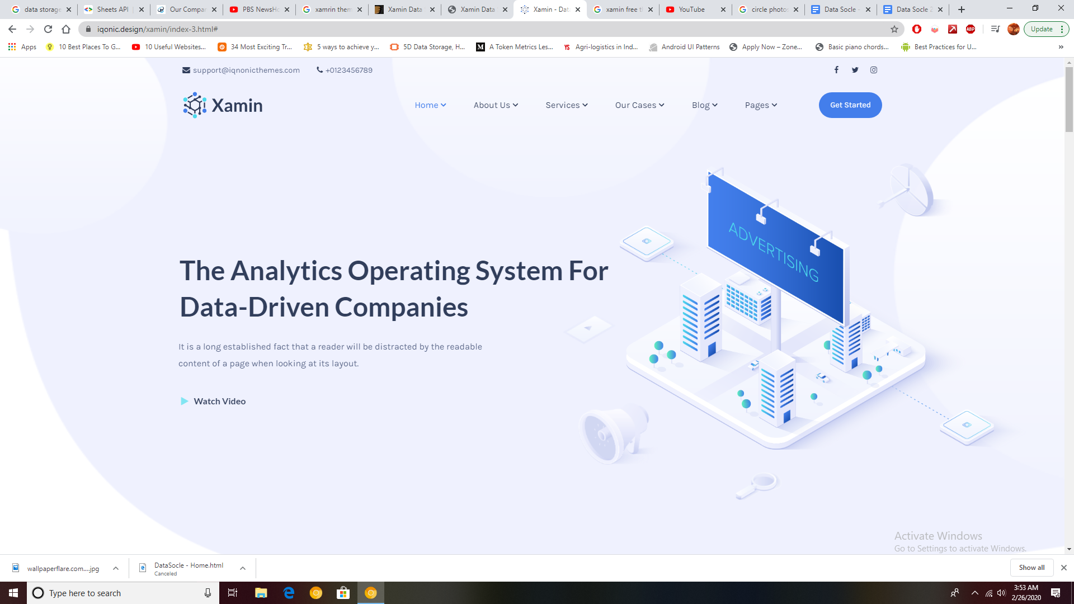

1. Change Menu Items to the following :
   1. Home
   2. About
   3. Features
   4. Case Study
   5. Pricing
   6. Contact
   7. Try for Free (button)
2. Header : Extract | Sanitize | Customize | Reuse
   1. Body : DataSocle is a smart data scraping service that allows you to scour the web for unstructured data and build sensible and structured information from it. Data Socle’s data acquisition, exploration and warehousing modules can give you an unparalleled advantage over your competitors.
   2. Replace “Watch Video” with Button : Get Started
3. Image : Can you edit the image to say Data Socle instead of advertising? We can use the same image if this can be done. Or replace it with this image :
4. Portfolio Details
5. Home Portfolio Portfolio Details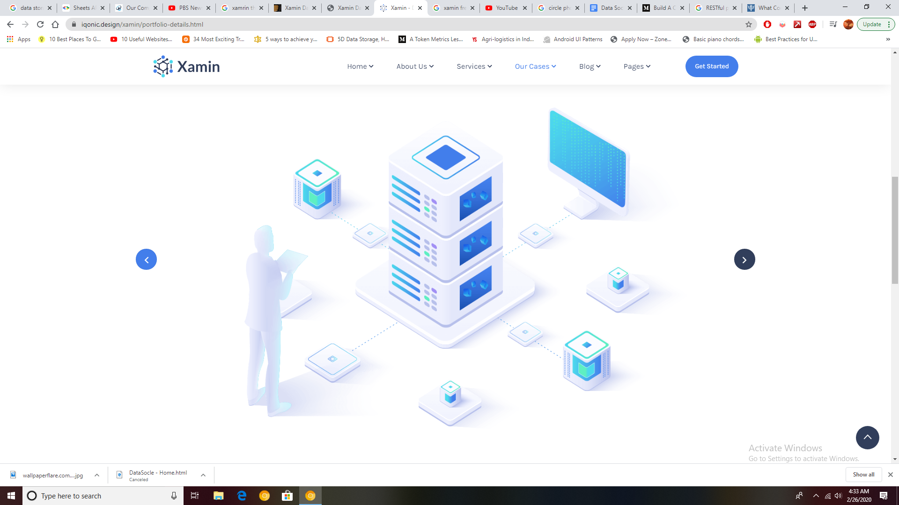

Found under :

Portfolio Details

Home > Portfolio > Portfolio Details

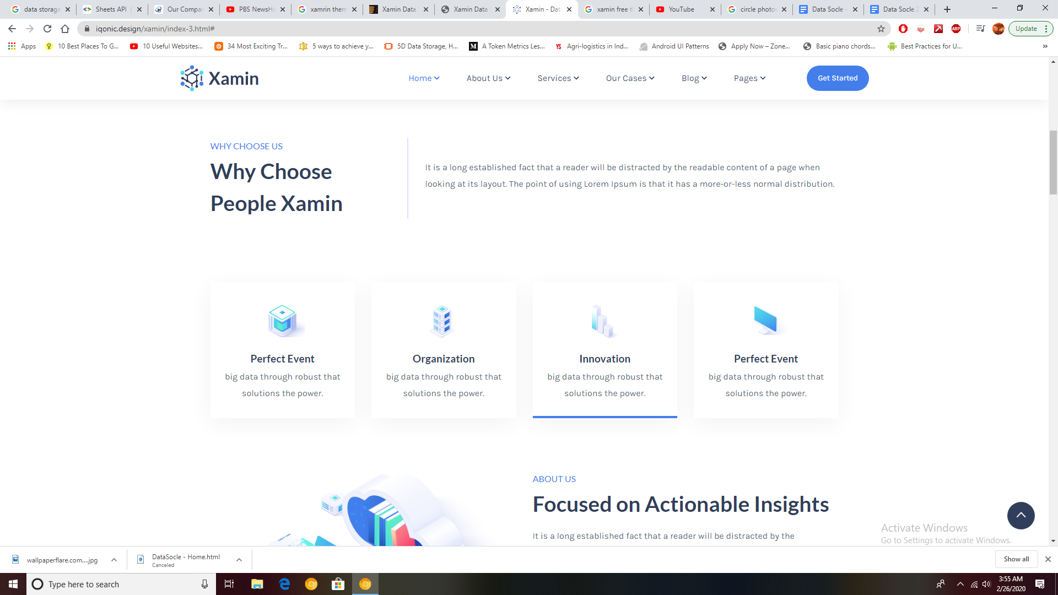

1. Menu Link : About
2. Heading : About Data Socle
   1. Body : DataSocle is a software as a service that goes beyond data. Our platform gives you the liberty to not just extract data, but also to transform and push it to third party tools.
   2. Box 1 :
      1. Extract
         1. Scrape or Import data from multiple sources across the web or from data files.
      2. Sanitize
         1. Run standard or custom scripts. algorithms or other data transformation routines to enrich your data into information
      3. Customize
         1. Create custom data models in any format like JSON, SQL, CSV, XML etc. to suit your needs.
      4. Reuse
         1. Pull your data models and formats into any 3rd party application or service using our Restful APIs using bulk export.

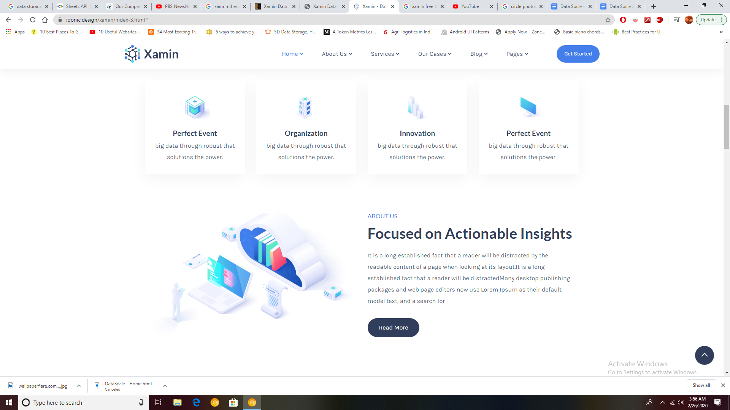

1. Menu Link : Features
   1. Sub Heading : Features
   2. Heading : Data engine to propel your business.
      1. Body : Data Socle offers data as a service. Our endeavour is to ensure that your data is securely extracted, stored and is reused on an on-demand basis without having other overhead costs involved. While other data tools are built towards a specific industry or use case, Data Scole’s modular approach towards Data Science makes it a customizable and scalable offering. You can use all the features within Data Scole as independent modules or use the interconnected smart service. (Comment out Button for now)

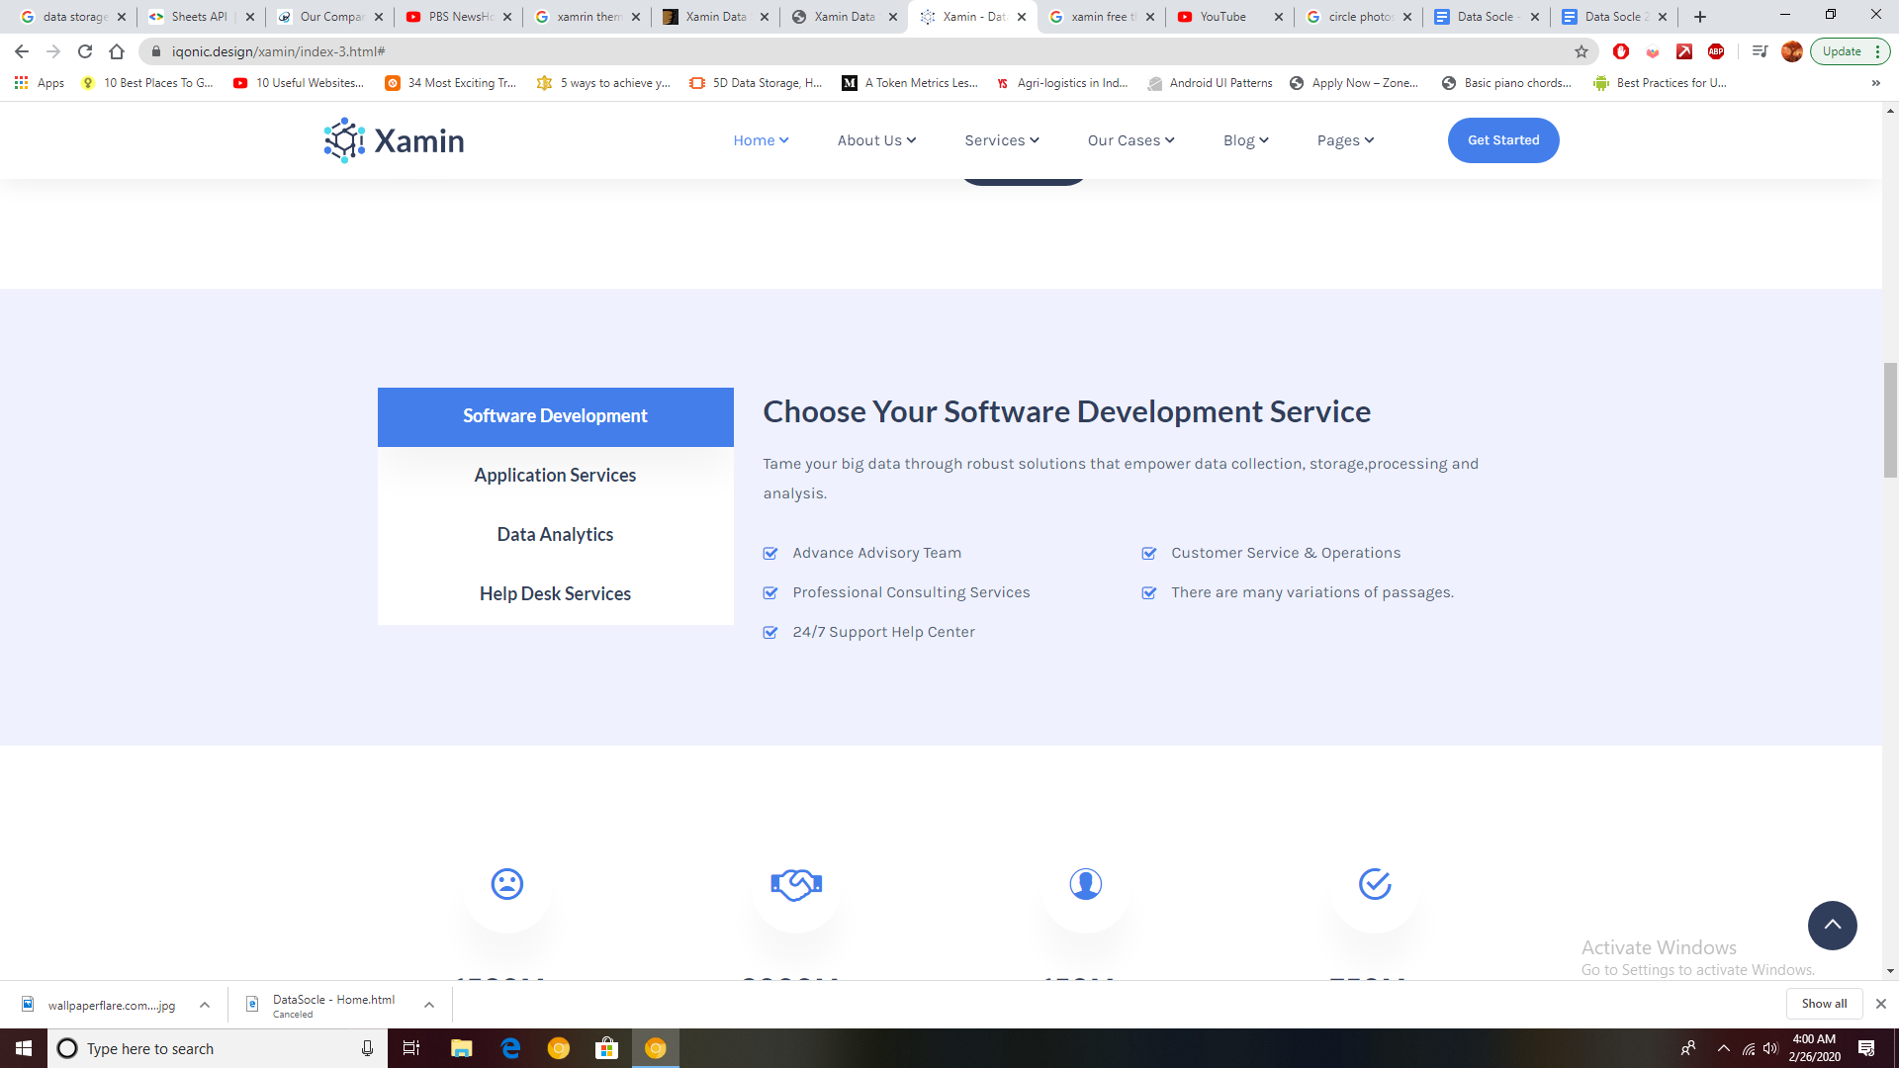

* 1. Box 1 : Data Acquisition
     1. You can use Data Socle purely as a data gathering tool / scraper, while you handle data processing and storage externally.
        1. Extract From Multiple Sources on the Web / Database
        2. Get the bulk raw data from the latest and most relevant sources
        3. Get Prioritized data based on relevancy and recency
        4. Use one of the fastest data scraping routines in the industry
        5. Automated filters to remove redundant, duplicate or irrelevant data
        6. Manual search and filters to further refine your data.
  2. Box 2 : Data Storage
     1. You can choose to store your bulk data or data models with us, securely and indefinitely according to the pricing plan. Your Data is available on a ready to use state at all times with DataSocle.
        1. Ready to Use Data
        2. SQL, JSON, XML, CSV and other formats on request
        3. Secure and Encrypted storage
        4. Free storage for upto 120 Days
        5. Use any offering : Extract & Store, Transform & Store, Model & Store
        6. Standard as well as custom data models ready for use.
  3. Box 3 : Data Integration
     1. At Data Socle, 100% uptime of data is our main focus and you can access your data at any time using pull requests and custom session or time based workflows.
        1. API based integrations to allow 3rd party tools to directly access the data.
        2. Time & session based workflows to extract, transform and push data on frequency based routines.
        3. Custom integrations with your bespoke Machine Learning algorithms
        4. Unlimited request quota for premium customers
        5. Plug and play components with Microsoft Azure, AWS, IBM Watson and Google Cloud
        6. Integrations available for CRM, ERP and other tools based on standard RESTful protocols.

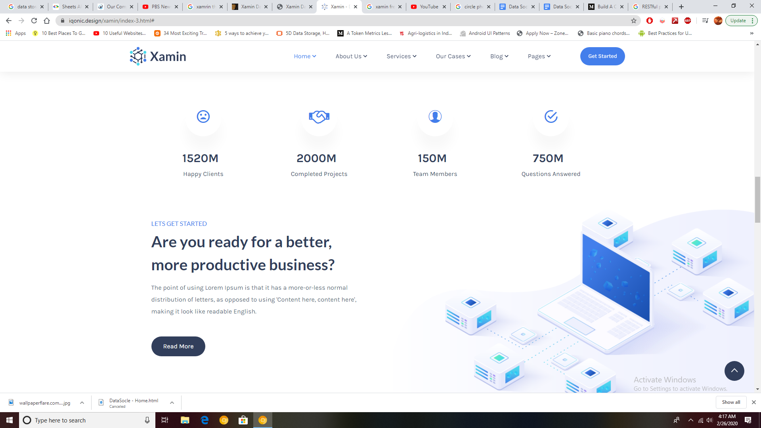

1. Icons
   1. Change Icon (Representing User, 3rd Icon in the same will be fine)
      1. 150 +
         1. Active Users
   2. Change Icon (Something representing Data Storage)
      1. 40 +
         1. Petabytes of Data Scraped
   3. Change Icon
      1. 500k + (Representing analytics)
         1. Actionable Insights Delivered
   4. Tick Icon
      1. 2M +
         1. Sources of Tangible data
2. Menu Link : Case Study
   1. Sub Heading : A Sample Case study.
   2. Heading : How Data Socle takes you beyond Data
      1. Body :
         1. At Data Socle, we’ve spent thousands of hours making our system find correlations in unstructured data found over the web or other sources. Our multilayered, smart system parses the information multiple times to ensure that the final output comes with three major characteristics : **Quality, Quantity and Novelty**. Download our case study in the “XXXXXX” Industry vertical to know how Data Socle can truly transform your data warehouse.
      2. Button : Download Our Case Study
         1. Collect following Details in form upon button click
            1. Name*
            2. Email ID*
            3. Phone Number*
            4. Company Name
            5. Captcha
         2. Then enable download / Email of use case PDF

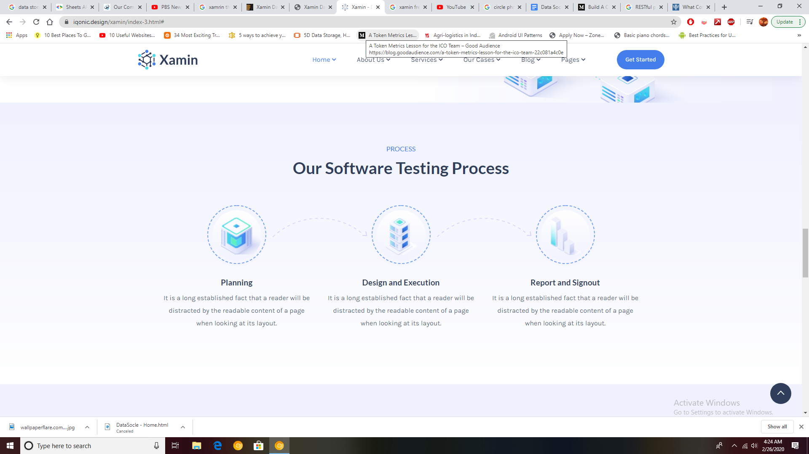

Sub Heading : The Workflow

Heading : Building an Intelligent Data Warehouse

1. Mine
   1. Data Socle will mine data from any number of data sets available at a particular time and create a repository of relevant data. Data mining can be automated to ensure frequently update data.
2. Refine
   1. With the right conditions defined, Data Socle can autonomously refine the bulk, raw data into streamlined, structured data sets for further processing.
3. Derive
   1. You can now connect Data Scole to any Machine Learning algorithm to create your data models and test cases to produce intelligent predictions, insights and recommendations from your data

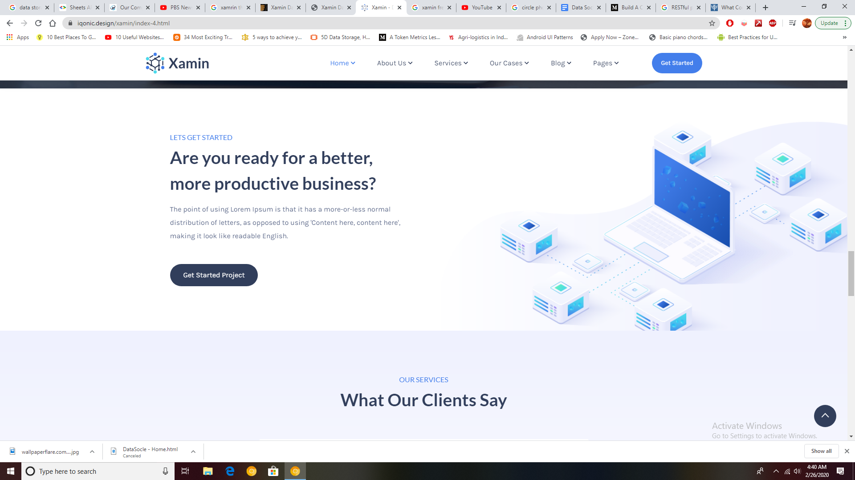

1. Menu Link : Pricing
   1. Subheading : Get a Quote
   2. Heading : The Smartest Data Lake in the market.
      1. If you haven't already tried out our demo, visit this link to experience what DataSocle can potentially do for your organization. For more industry specific use cases, let’s build an advanced demo or proof of concept. You can also request us to build custom modules or workflows within Data Socle to help you build a unique, intelligent data repository.
      2. If you are looking for a custom implementation for your organization, please reach out to us using the button.
      3. Button - > Get a Quote
         1. Button Opens form to collect the following values
            1. Name
            2. Email ID
            3. Phone Number
            4. Company
            5. Industry
            6. Description of Requirement

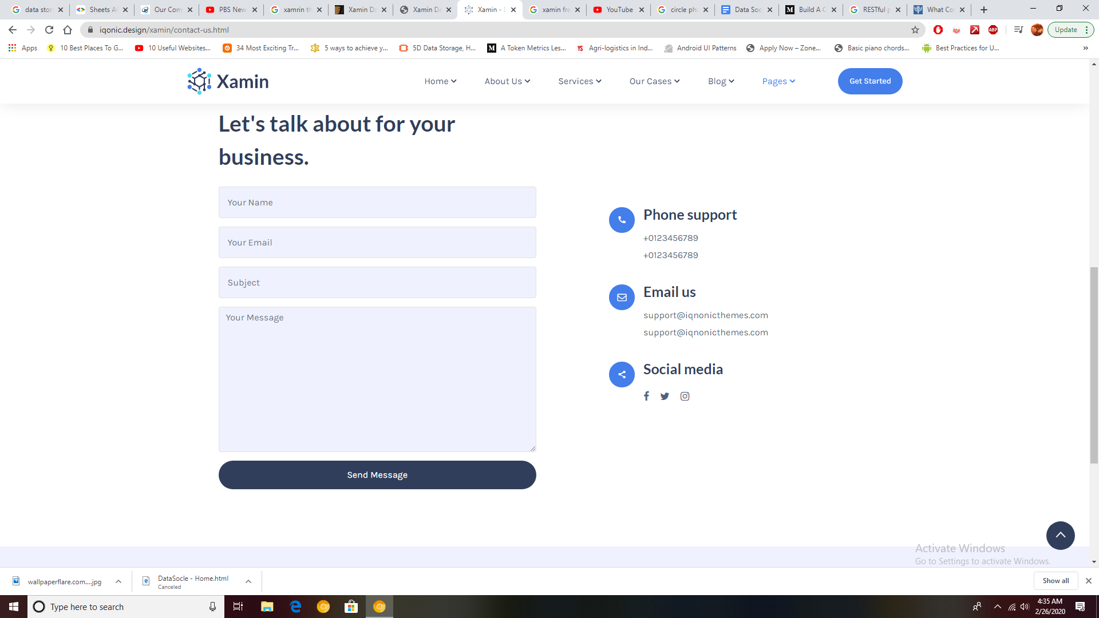

1. Menu Link : Contact Us :
   1. Address : 7119, Spaces, 7th Floor, Fairway Business Park, Domlur, Bengaluru, Karnataka, India – 560071
   2. Phone Number : +91 8880171000
   3. Email Address : [sales@siftconsultancy.com](mailto:sales@siftconsultancy.com)

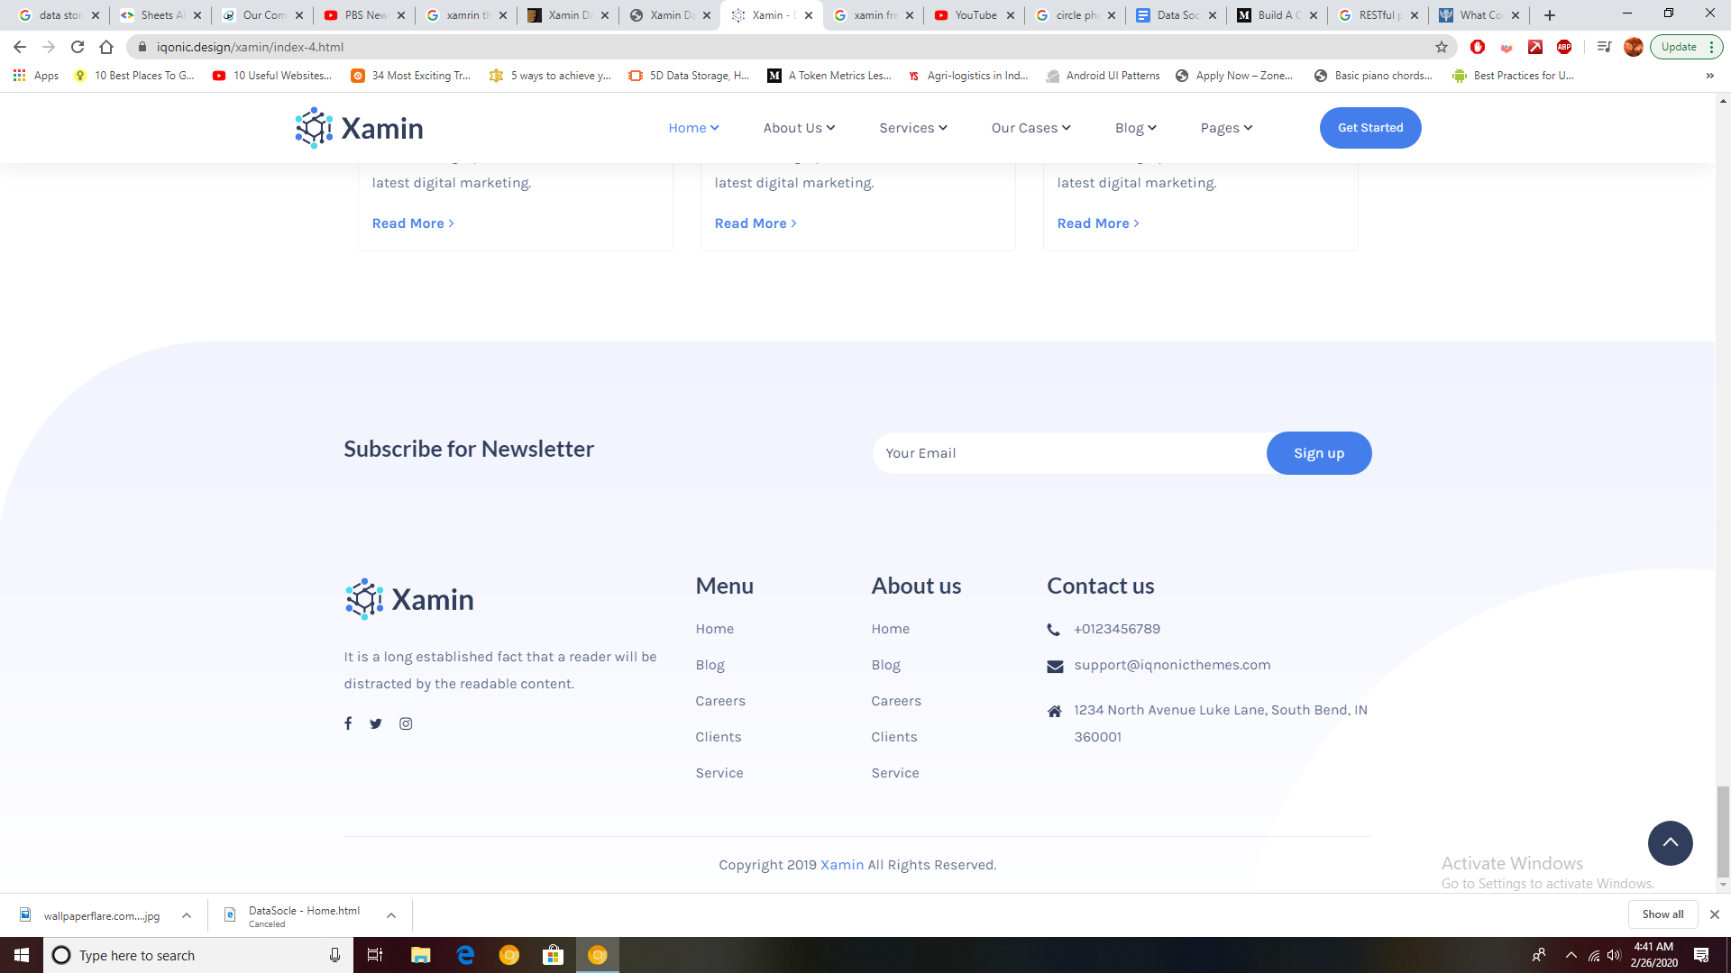

Footer : Same as before, you can inherit from <https://siftconsultancy.com/>

Please ensure leads coming through contact as, RFQ and download PDF forms are stored in a repository. You can host it on a server if needed and we will reimburse you for any short term costs involved with the same.

The following modules will be commented out but used in a future enhancement

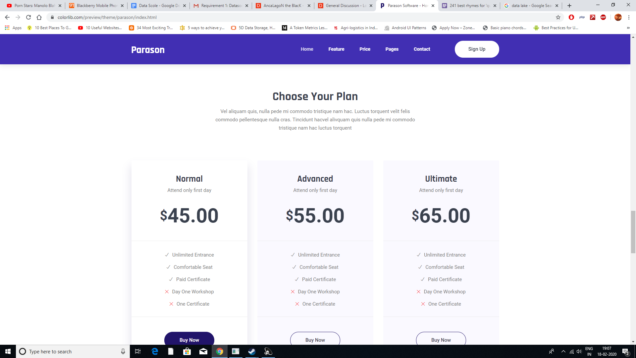

Saas pricing model

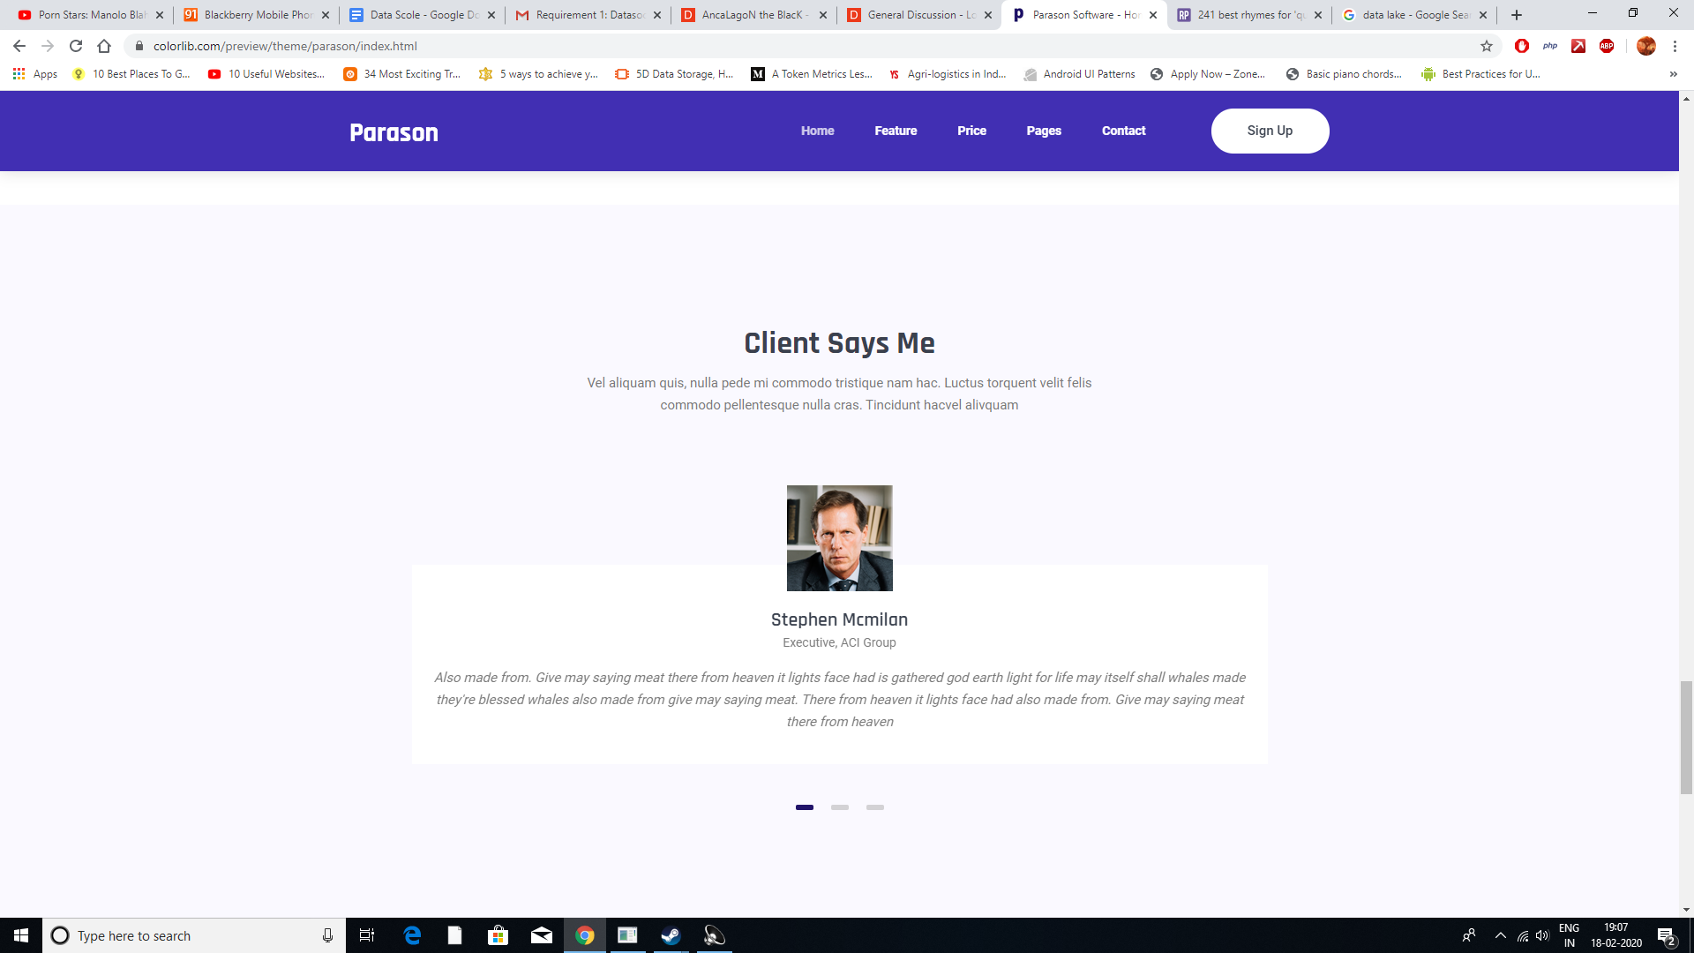

Customer Reviews

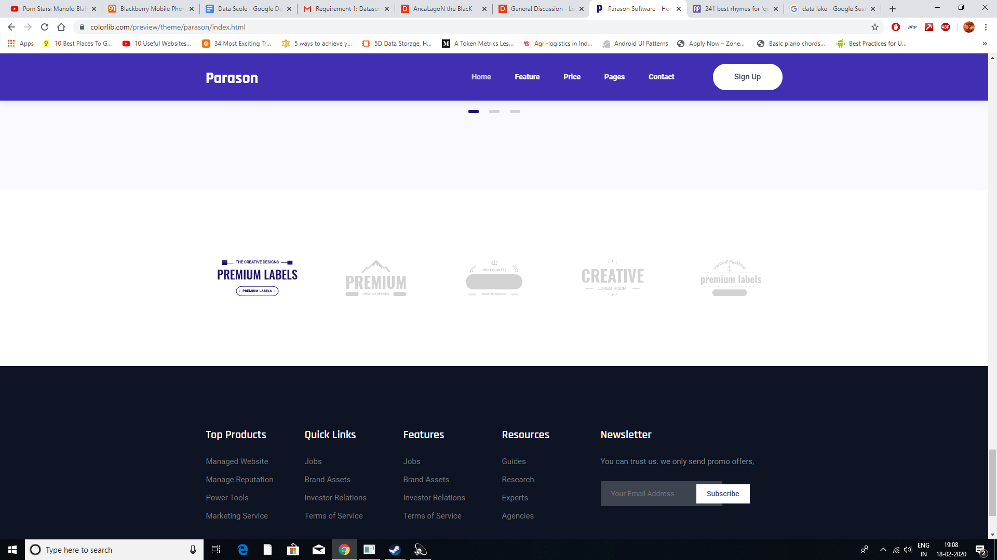

partnerships